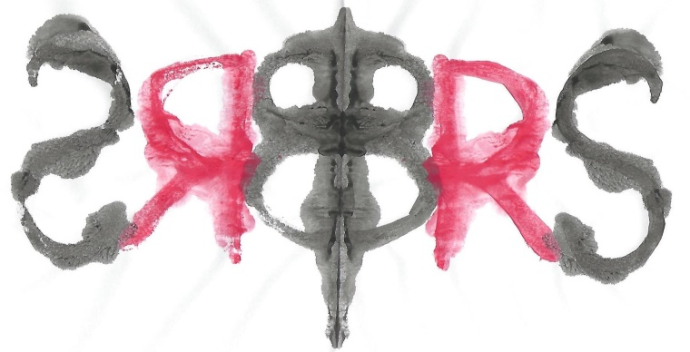

**The British Rorschach Society**

**Invites you to our**

**Annual Case Presentation**

**On**

**Monday 2nd December 2024**

**4pm to 6pm**

**At**

**222 Upper Street**

**London**

**N1 1XR**

Dr Patrick Halcrow will be presenting one of his cases. This will provide the attendees an opportunity to discuss how the Rorschach data and projective methods contribute to the formulation and understanding of the examinee’s personality functioning in the light of the referral question. Dr Kari Carstairs will provide some preliminary thoughts on the case and then the discussion will be open to the audience.

*This event is free for all members of the British Rorschach Society.*

*Non-members are very welcome to join us and will be asked to pay £20 per person.*

*Please contact Dr Marc Desautels* [*marc@desautels.com*](mailto:marc@desautels.com)

*to confirm your attendance.*